How to use Zoom:

To sign in, use your Zoom, Google, or Facebook account. You can also log in using SSO. If you don't have an account, click Sign Up Free. If you have a Zoom account but cannot remember your password, click Forgot.
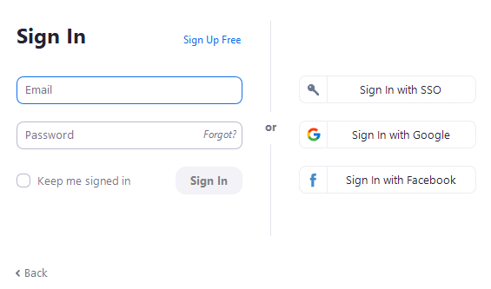

Home
After signing in, you will see the Home tab, where you can click these options:
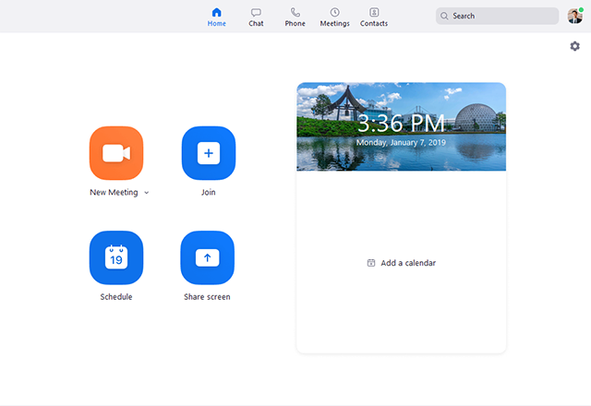
- New Meeting: Start an instant meeting. Click the downwards arrow to enable video or use your personal meeting ID (PMI) for instant meetings.
- Join: Join a meeting that is in progress.
- Schedule: Set up a future meeting.
- Share Screen: Share your screen in a Zoom Room by entering in the sharing key or meeting ID.

You can have a general chat with people by messaging on Zoom, without having to go on a video/audio call by clicking on a contact and “Chat’’ button.

